TNE20003 – Internet and Cybersecurity for Engineering Applications

**Portfolio Task – Lab 2 Pass**

**Task**

Aims:

* To subnet a network according to the given class address and network diagram

Preparation:

* View [“IP Subnetting"](https://swinburne.instructure.com/courses/54168/pages/ip-subnetting?module_item_id=3692170) & “[IP address and subnetting task-1”](https://swinburne.instructure.com/courses/54168/pages/ip-subnetting?module_item_id=3692170) & “[Network Addressing & Subnetting”](https://swinburne.instructure.com/courses/54168/pages/ip-subnetting?module_item_id=3692170)

Task Completion

* Upon completion of this task you are to demonstrate and explain your successful subnetting to the lab instructor who will then mark you as having completed this task. Your instructor will ask you some questions to allow you to show the depth of your understanding.

Due Date:

* All tasks in this lab are to be completed and demonstrated to your Lab instructor preferably during or at the end of the current lab, but if you do not complete the tasks you may demonstrate it at the beginning of your next lab class.

Subnet and Address a Network According to Provided Requirements

In this task, you will

* Undertake the subnetting needed for the network shown in the diagram below and provide Addressing for each network/subnetwork in that diagram.

Instructions

1. Using the examples provided in the documents under the tutorial section under modules on Canvas for this unit, carry out the relevant subnetting to completely address the network shown below.

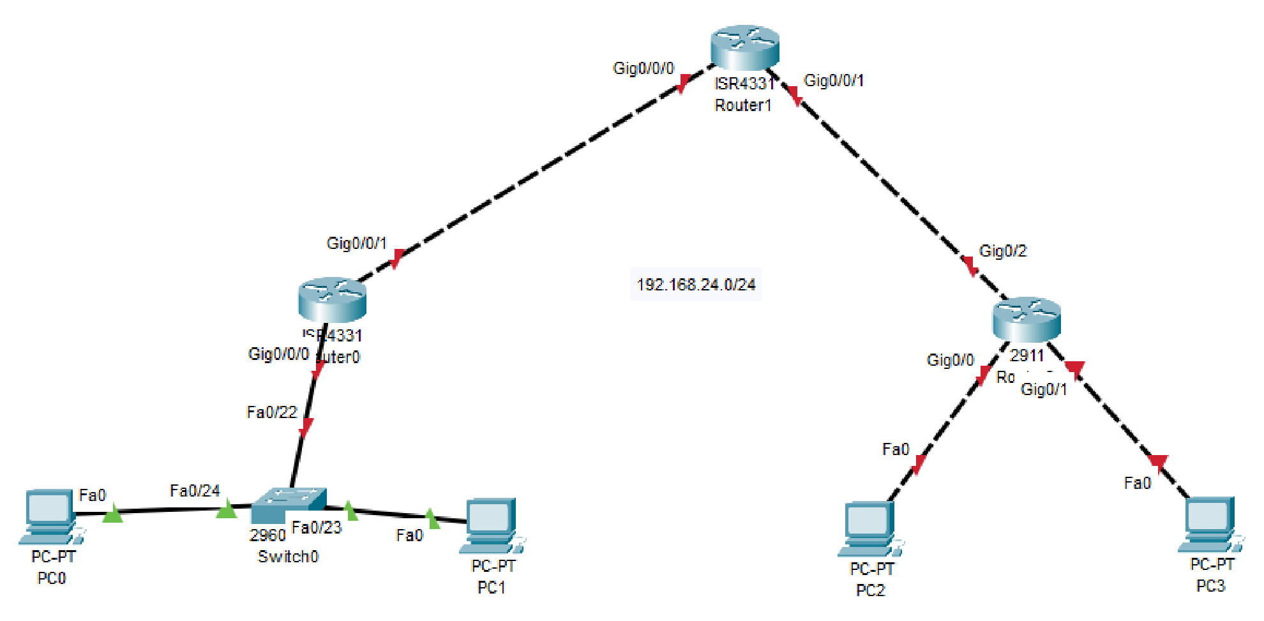

200.200.100.

0

/

2

5

Some things you may want to consider are:

* What class of network is the given address? This is a class C n/w because it is in the -> This is class C as the first decimal is from the range of 192 to 223.
* How many networks do I have in the diagram?

-> There are 5 networks in the topology.

* How many host addresses do I need per network/subnetwork? There are 4 bits left 3

Each network have 3 host addresses, 2 PCs and 1 Router, each router has 2 link addresses.

|  |  |  |  |
| --- | --- | --- | --- |
| Host | Network | SM | First Usable |
| 3 | 200. 200.100.0 | /28 | 200. 200.100.1 |
| 2 | 200. 200.100.16 | /28 | 200. 200.100.17 |
| 2 | 200. 200.100.32 | /28 | 200. 200.100.33 |
| 2 | 200. 200.100.48 | /28 | 200. 200.100.49 |
| 2 | 200. 200.100.64 | /28 | 200. 200.100.65 |

WORKING OUT

Five networks in total, including the connection from Router0 to Switch0, Router 2 to 2 PCs and the two connections between Router1 and the two contigous Routers.

With five networks, the subnet mask’s adjustment need to borrow three bits from the host address since 2^3 > 5. Breaking down the adjustment to the binary, it is 11111111.11111111.11111111.1111000. Therefore, the new subnet mask will be /28. Which change the number of possible host address, to 2^4 - 2 = 14 host addresses (formula).

***Sample solution shown below***

*of document*

**Portfolio Task – Lab 2 Credit**

**Task**

Aims:

* Using the addressing you carried out in the Pass Task of this lab you must build and implement an addressed network according to the given network diagram below on Packet Tracer (PT)

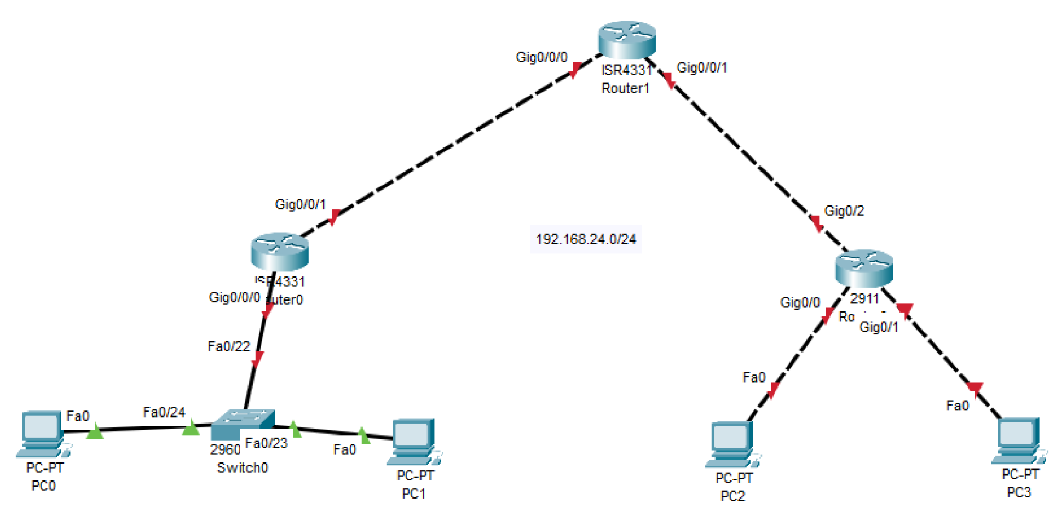

200.200.100.

0

/2

5

Preparation:

* View “[TNE20003 Lab1-P_Student”](https://swinburne.instructure.com/courses/54168/assignments/567094) for instruction on Packet Tracer implementation.

Task Completion

* Upon completion of this task you are to demonstrate your network implemented on PT. Your lab instructor will then mark you as having completed this task. Your instructor will ask you some questions to allow you to show the depth of your understanding.

Due Date:

All tasks in this lab are to be completed and demonstrated to your Lab instructor preferably during or at the end of the current lab, but if you do not complete the tasks you may demonstrate it at the beginning of your next lab class.

**Portfolio Task – Lab 2**

**Distinction Task**

Aims:

* Demonstrate successful end-to-end connectivity of the addressed network implemented in Packet Tracer from the Credit Task above.

Preparation:

* Using Self-Directed learning find out about static routes
* What are they?

-> Static routes are manually configured routes in a network's routing table Each static route specifies a destination network or a specific host and the next gateway through which traffic should be forwarded to reach that destination.

* What are they used for?

-> Default Routes: Defining a default route (0.0.0.0/0) for traffic that does not match any other routes. This is often used as a "catch-all" route for sending traffic to a default gateway.

Specific Network Routes: Forwarding traffic to specific networks or subnets via a designated gateway.

Backup Routes: Creating redundant paths for failover or load balancing purposes.

Isolated Networks: Connecting isolated networks that do not need dynamic routing protocols.

* How do you implement them?

->By following these steps:

1. Access configuration interface

2. Enter configuration mode

3. Configure static route

4: Specify the destination network

5. Exit configuration mode

6. Verify static route

7. Test

* Which device(s) are they placed on?

->Static routes are typically placed on routers or layer 3 switches. These devices are responsible for making routing decisions and directing traffic between different networks.

* Static routes are vital for you to be able to achieve end-to-end Connectivity.

Task Completion

* Upon completion of this task you are to demonstrate and explain your successful implementation of static routes to the lab instructor who will then mark you as having completed this task. Your instructor will ask you some questions to allow you to show the depth of your understanding.

Due Date:

All tasks in this lab are to be completed and demonstrated to your Lab instructor preferably during or at the end of the current lab, but if you do not complete the tasks you may demonstrate it at the beginning of your next lab class.

# ~~~~~ End of Lab ~~~~~